

|  |
| --- |
| Principles of Big Data  Phase 2 Draft Report |
|  |
| May 5  Kota Chakra Pavan Kumar Sai Kumar Reddy Seelapureddy  Ajith Kumar Guduru |

# Twitter Data Analysis using Spark

|  |
| --- |
| Phase 2 |

Country wise tweets graph shows the tweets counts based on country in a cool globe. 500 MB of Tweets are collected for this analysis and crunched with spark using the below query.

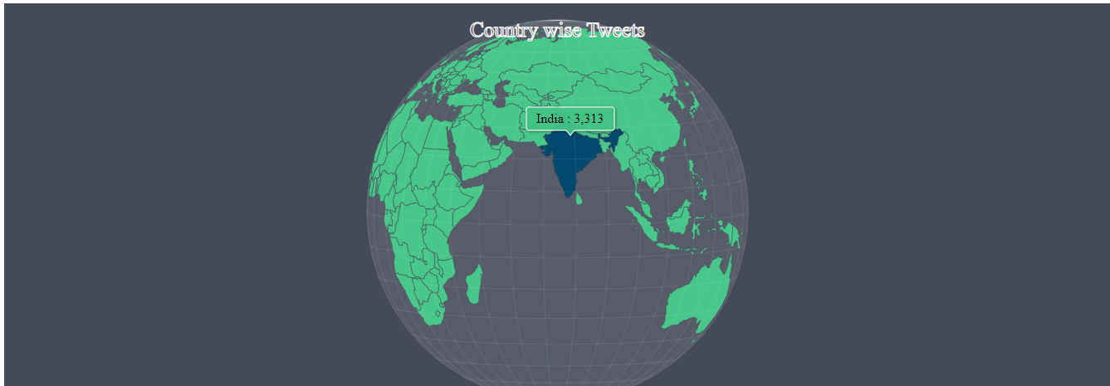

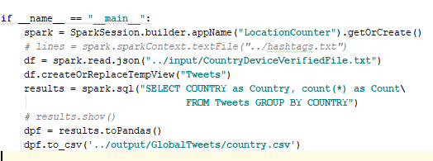

A python web api that returns the previously analyzed country wise data is created here

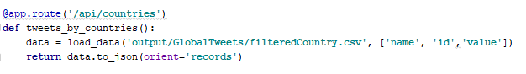

This visualization depicts the global response to an event (Avengers) from the tweets. The result is bucketed based on countries from where the tweets are arrived

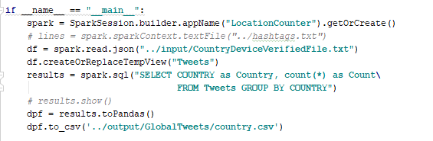

A python web api that returns the previously analyzed country wise data is created here

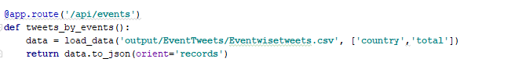

The above stacked bar chart is a visualization of data analysis on the devices from which tweets are generated across the globe.

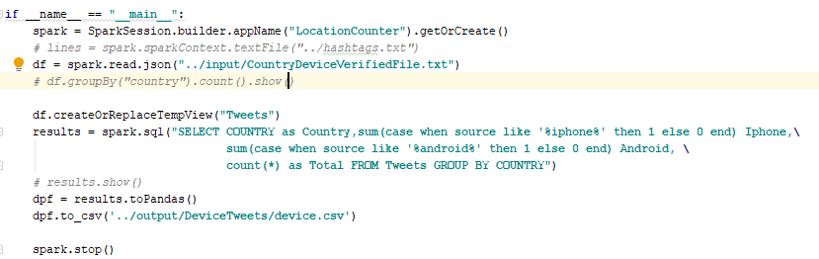

A python web api that returns the previously analyzed data is created here

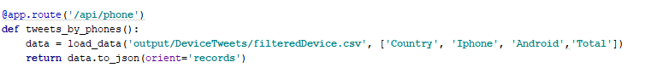

Sai

A python web api that returns the above-mentioned analyzed data is created here

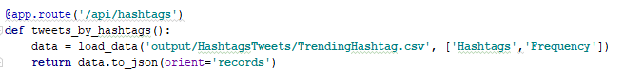

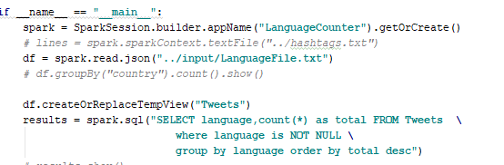

A python web api that returns the above-mentioned analyzed data is created here

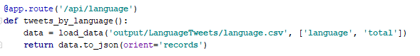

Sai

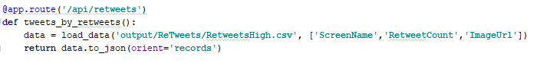

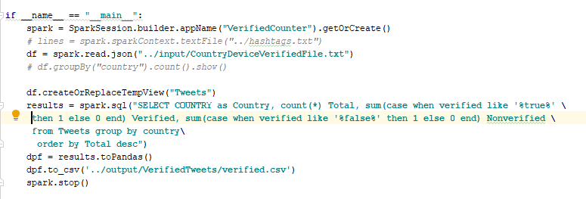

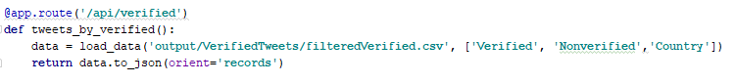

Sai

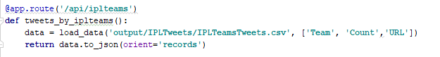

Sai

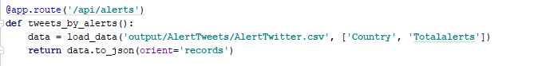

GRAPH 10

GITHUB LINK